#### **Target – case study using SQL**

**Context**

Target is one of the world’s most recognized brands and one of America’s leading retailers. Target makes itself a preferred shopping destination by offering outstanding value, inspiration, innovation and an exceptional guest experience that no other retailer can deliver.

This business case has information of 100k orders from 2016 to 2018 made at Target in Brazil. Its features allows viewing an order from multiple dimensions: from order status, price, payment and freight performance to customer location, product attributes and finally reviews written by customers.

**High level overview of relationship between datasets:**

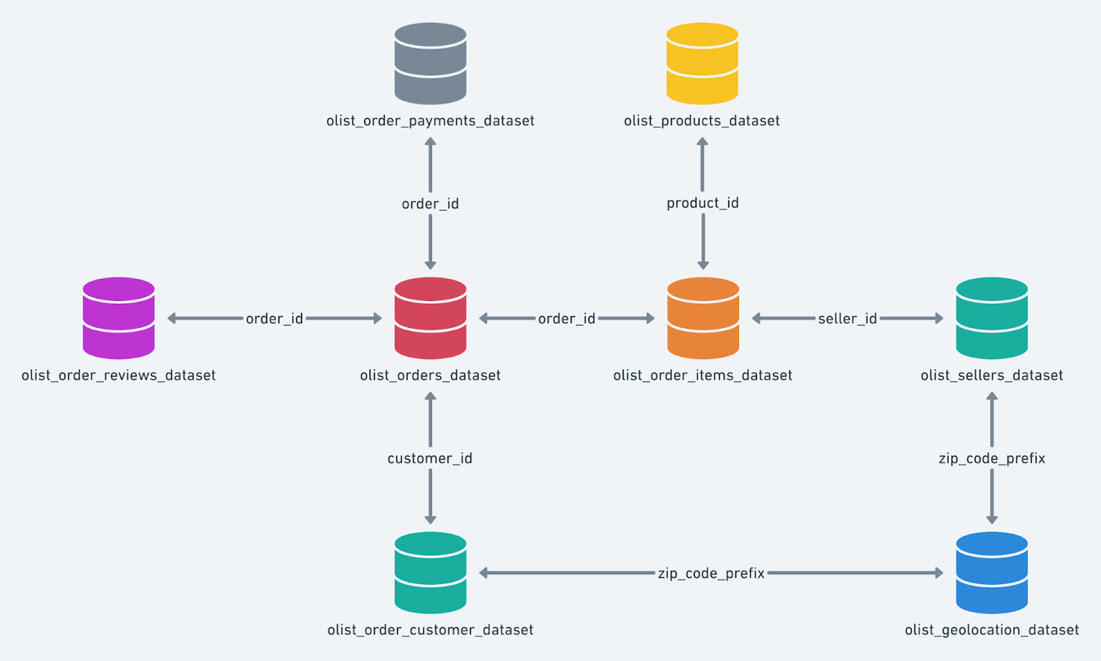

1. Import the dataset and do usual exploratory analysis steps like checking the structure & characteristics of the dataset
   1. Data type of columns in a table

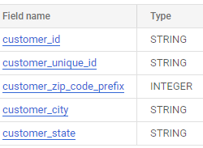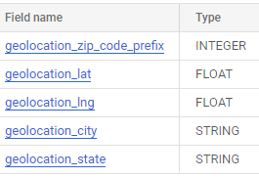

* 1. Time period for which the data is given

select extract(year from min(order_purchase_timestamp)) as min_year,

extract(year from max(order_purchase_timestamp)) as max_year from `my-project-target-382813.Target.orders` ;



* 1. Cities and States of customers ordered during the given period

SELECT distinct customer_city, customer_state FROM `my-project-target-382813.Target.customers` ;

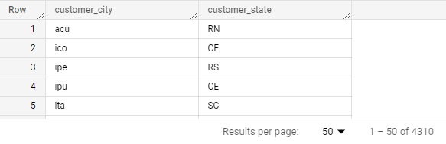

1. In-depth Exploration:
   1. Is there a growing trend on e-commerce in Brazil? How can we describe a complete scenario? Can we see some seasonality with peaks at specific months?

SELECT  extract(year from order_purchase_timestamp) as year,

extract(month from order_purchase_timestamp) as month , count(order_id) as No_of_orders  FROM `my-project-target-382813.Target.orders` group by year, month order by  year,month;

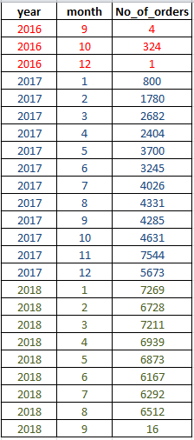

**Yes, There’s a Increased growth on e-commerce in brazil. In the year 2016 there was a slow growth and later at the start of 2017 there was good increase in growth when compared to previous year and then in the year 2018 there was a static no. of orders until august.**

select u.* from (select  t.*, avg(No_of_orders)over(partition by year) as avg_orders

from (SELECT  extract(year from order_purchase_timestamp) as year,

extract(month from order_purchase_timestamp) as month , count(order_id) as No_of_orders,

FROM `my-project-target-382813.Target.orders` group by year, month order by  year,month) t)u

where No_of_orders > avg_orders order by year, month ;

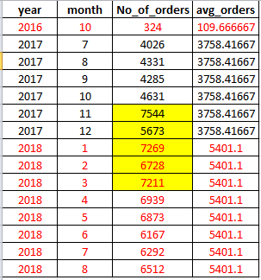

**Yes, At specific months like November and December of 2017, January, February and march of 2018 are peak in no. of orders.**

* 1. What time do Brazilian customers tend to buy (Dawn, Morning, Afternoon or Night)?

SELECT  extract(hour from order_purchase_timestamp) as hour,

count(order_id) as No_of_orders  FROM `my-project-target-382813.Target.orders`

group by hour order by  hour;

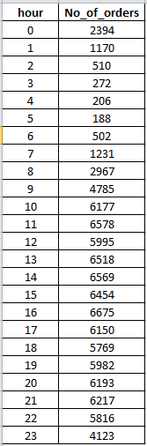

select distinct Time_tend_to_buy,sum(No_of_orders)over(partition by Time_tend_to_buy)

as sum_of_orders

from (with c as (SELECT  extract(hour from order_purchase_timestamp) as hour,

count(order_id) as No_of_orders  FROM `my-project-target-382813.Target.orders`

group by hour order by  hour) select *, case when hour >= 0 and hour < 7 then 'dawn'

                          when hour >= 7 and hour < 11 then 'morning'

                          when hour >= 11 and hour < 18 then 'afternoon'

                          when hour >=18 and hour <= 23 then 'night'

                          end as Time_tend_to_buy from c) u;

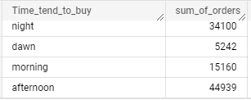

**Therefore, Afternoon between 11:00 to 18:00 customers tend to buy more.**

1. Evolution of E-commerce orders in the Brazil region:
   1. Get month on month orders by states

SELECT  extract(month from order_purchase_timestamp) as month , B.customer_state,

count(A.order_id) as No_of_orders  FROM `my-project-target-382813.Target.orders` A

join `my-project-target-382813.Target.customers` B on A.customer_id = B.customer_id

group by B.customer_state, month order by  month, B.customer_state;

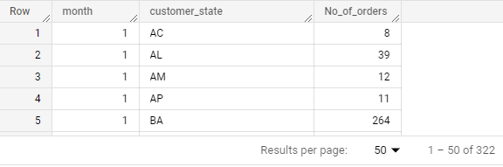

* 1. Distribution of customers across the states in Brazil

select customer_state, count(customer_id) as no_of_customers from `my-project-target-382813.Target.customers` group by customer_state order by no_of_customers;

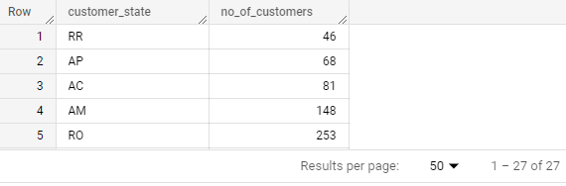

1. Impact on Economy: Analyse the money movement by e-commerce by looking at order prices, freight and others.

select order_item_id, extract(year from shipping_limit_date) as year,  avg(price) as avg_price, avg(freight_value) as avg_freight_val from `Target.order_items` group by year, order_item_id order by order_item_id, year;

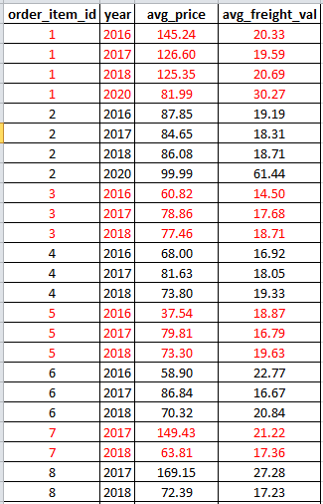

* 1. Get % increase in cost of orders from 2017 to 2018 (include months between Jan to Aug only) - You can use “payment_value” column in payments table

select year, sum(payment_value) as cost_of_orders  from (select extract (year from shipping_limit_date) as year,extract (month from shipping_limit_date) as month, p.payment_value from `Target.payments` p join `Target.order_items` o on o.order_id = p.order_id) t where (month >=1 and month<= 8) and year<=2018 group by year order by year;

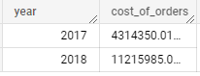

with c as(select year, sum(payment_value) as cost_of_orders  from (select extract (year from shipping_limit_date) as year,extract (month from shipping_limit_date) as month, p.payment_value from `Target.payments` p join `Target.order_items` o on o.order_id = p.order_id) t where (month >=1 and month<= 8) and year<=2018 group by year order by year)

selectround(((cost_of_orders -lag(cost_of_orders)over(order by year asc ))/lag(cost_of_orders)over(order by year asc )) * 100)

as percentage_increase from c  ;



* 1. Mean & Sum of price and freight value by customer state

select distinct customer_state, round(avg(price)over(partition by customer_state),2) as avg_price, round(sum(price)over(partition by customer_state),2) as sum_price, round(avg(freight_value)over(partition by customer_state),2) as avg_freight_value, round(sum(freight_value)over(partition by customer_state),2) as sum_freight_value from Target.customers c join Target.orders o on c.customer_id = o.customer_id join Target.order_items oi on o.order_id = oi.order_id order by customer_state;

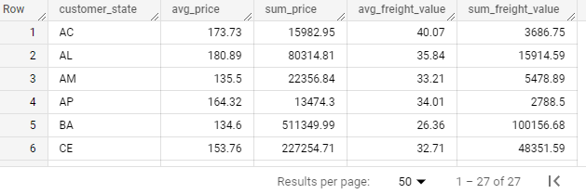

5. Analysis on sales, freight and delivery time

1. Calculate days between purchasing, delivering and estimated delivery

select order_id,date_diff( order_estimated_delivery_date , order_purchase_timestamp, day) as estimated_days, date_diff(order_delivered_customer_date , order_purchase_timestamp, day) as delivered_days  from Target.orders;

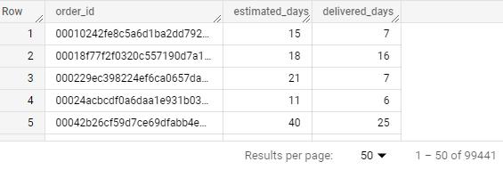

1. Find time_to_delivery & diff_estimated_delivery.

Formula for the same given below:

* + time_to_delivery = order_purchase_timestamp - order_delivered_customer_date
  + diff_estimated_delivery = order_estimated_delivery_date -order_delivered_customer_date

select order_id, date_diff( order_delivered_customer_date , order_purchase_timestamp, day) as time_to_delivery, date_diff(order_estimated_delivery_date , order_delivered_customer_date, day) as diff_estimated_delivery  from Target.orders order by order_id;

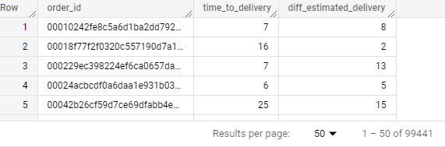

1. Group data by state, take mean of freight_value, time_to_delivery, diff_estimated_delivery

select distinct state, mean_freight_val, round(avg(time_to_delivery)over(partition by state),2) as mean_time_to_delivery, round(avg(diff_estimated_delivery)over(partition by state),2) as mean_diff_estimated_delivery from

 (select customer_state as state, round(avg(freight_value)over(partition by customer_state),2) as mean_freight_val,

date_diff( order_delivered_customer_date , order_purchase_timestamp, day) as time_to_delivery, date_diff(order_estimated_delivery_date , order_delivered_customer_date, day) as diff_estimated_delivery

from Target.customers c join Target.orders o on c.customer_id = o.customer_id join Target.order_items oi on o.order_id = oi.order_id order by customer_state)t order by state;

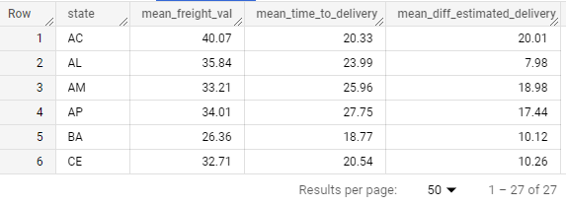

1. Sort the data to get the following:

************ can also be done by considering above table as cte ************

1. Top 5 states with highest/lowest average freight value - sort in desc/asc limit 5

**Highest average freight value :**

select distinct state, mean_freight_val  from (select customer_state as state, round(avg(freight_value)over(partition by customer_state),2) as mean_freight_valfrom Target.customers c join Target.orders o on c.customer_id = o.customer_id join Target.order_items oi on o.order_id = oi.order_id order by customer_state) t

 order by mean_freight_val desc limit 5;

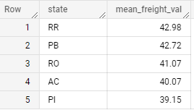

1. Top 5 states with highest/lowest average time to delivery

**Lowest average time to delivery :**

select distinct state, round(avg(time_to_delivery)over(partition by state),2) as mean_time_to_delivery from

 (select customer_state as state, date_diff( order_delivered_customer_date , order_purchase_timestamp, day) as time_to_delivery

  from Target.customers c join Target.orders o on c.customer_id = o.customer_id join Target.order_items oi on o.order_id = oi.order_id order by customer_state)t

order by mean_time_to_delivery asc limit 5;

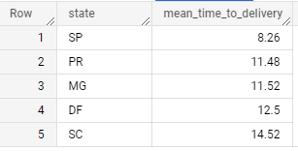

1. Top 5 states where delivery is really fast/ not so fast compared to estimated date

**Delivery is really fast when then mean_time_to_delivery is less than the mean_diff_estimated_delivery or when difference between them is less than 1.**

select state , mean_time_to_delivery, mean_diff_estimated_delivery, case when (mean_time_to_delivery < mean_diff_estimated_delivery) or (mean_time_to_delivery - mean_diff_estimated_delivery)<1

then "fast_delivery" else "not_so_fast" end as delivery

  from (select distinct state, round(avg(time_to_delivery)over(partition by state),2) as mean_time_to_delivery, round(avg(diff_estimated_delivery)over(partition by state),2) as mean_diff_estimated_delivery from

 (select customer_state as state, date_diff( order_delivered_customer_date , order_purchase_timestamp, day)  as time_to_delivery, date_diff(order_estimated_delivery_date , order_delivered_customer_date, day) as diff_estimated_delivery

  from Target.customers c join Target.orders o on c.customer_id = o.customer_id  order by customer_state)) order by delivery;

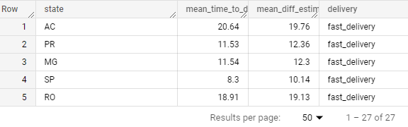

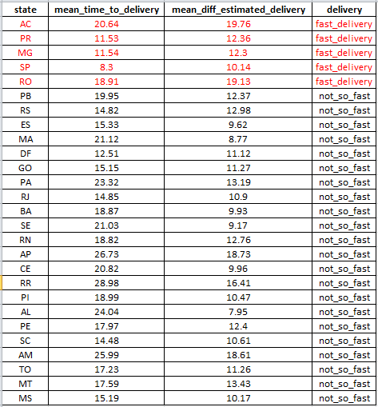

Top 5 states with fast_delivery marked in RED color out of 27 states.

6. Payment type analysis:

1. Month over Month count of orders for different payment types

select extract(month from(order_purchase_timestamp)) as month, count(o.order_id) as no_of_orders,payment_type from Target.orders o join Target.payments p on o.order_id = p.order_id group by month,payment_type order by month;

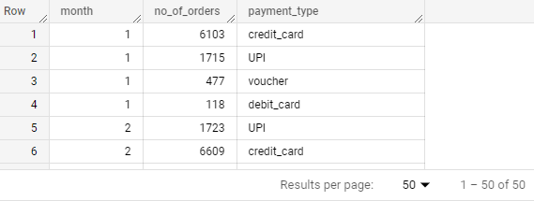

1. Count of orders based on the no. of payment instalments.

select  count(o.order_id) as no_of_orders, payment_installments from Target.orders o join Target.payments p on o.order_id = p.order_id group by payment_installments order by payment_installments;

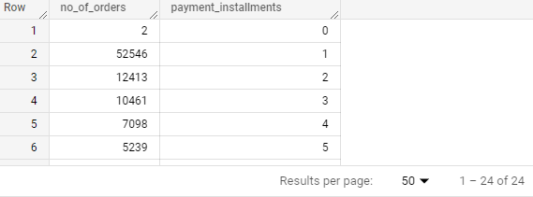

**Analysis by,**

**Name : Meghana S**

**Batch : DSML Feb23 Beginner**